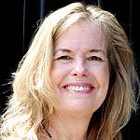
Susan Hedlund, MSW, LCSW, OSW-c

Susan Hedlund, LCSW, has been a social worker in the health care field for thirty years and has extensive experience working with individuals and families facing life threatening illness and loss. She is currently the Manager of Patient and Family Support Services at the Knight Cancer Institute at Oregon Health and Sciences University and is an associate professor at OHSU School of Medicine and PSU School of Social Work.

She is a past president of the Association of Oncology Social Work, received AOSW’s Leadership Award in 1999 and the ACS Quality of Life Award in 2009, and the Sojourn’s Award for Palliative Care in 2013.

