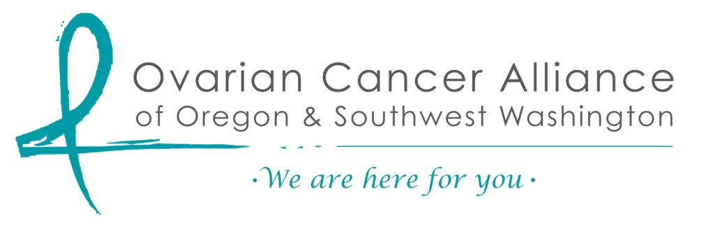

$750.00 Scholarship Request
National Ovarian Cancer Conference 2018
Washington DC: July 13 to July 16

Requirements:
- You must be a resident of Oregon or Southwest Washington
- Applications are no later than May 31, 2018
- Fill in the questions and send as an attachment to info@ovariancancerosw.org or mail to:
Ovarian Cancer Alliance of Oregon and SW WA
PMB 243, Suite 103
16420 SE McGillivray
Vancouver, WA 98683

NAME: ____________________________________________

ADDRESS: _________________________________________

PHONE: ___________________________________________

EMAIL: ____________________________________________

- What is your relationship to ovarian cancer (survivor, family member, advocate, etc.)?

- Have you attended the OCNA national conference before?

More on back……

- What do you want to gain for yourself by attending?

- How would you use your conference experience “back home?”

- Would a $750 scholarship make the difference in your attending the conference?

- Would you like to attend the conference but are unable to do so without more than a $750 scholarship?

- Will you attend Advocacy Day on Capitol Hill?

